**Technical Design Document**

**PROJECT NAME**:

ABC BANKING

TRUST AND EXCELLENCE

- KONDURU PRAVALLIKA

**INTRODUCTION:**

ABC Banking Trust and Excellence is an online loan application to make applying loans easier and simpler. The architecture implemented is Spring Boot Services.

**Functional Requirements:**

The functional requirements of the project are:

**For the Admin**:

* View users
* Search users
* Delete users

**For the User**:

* Login/Register
* Apply Loan
* Check Account Balance
* Deposit Balance
* Profile Details
* Foreclose
* View Transactions
* Calculate EMI
* Pay EMI

**SERVICES:**

The different services are:

**Apply Loan:**

When a user is already logged in, he/she is considered as authenticated user and he/she will be able to apply for loan. A user needs to enter loan amount, asset value and deposit amount. The loan amount should be a minimum of 10000 and asset value should be a minimum of 20000. If this criterion is not satisfied then the user will be prompted to enter the value within desired range. It will be verified that the asset value is 1.5 times greater than the loan value or not. If not then the user will be prompted to enter an asset of value 1.5 times greater than the loan amount. It will be verified that the deposit amount is 40% of the loan amount. After successful validation of these conditions, the user is granted the loan and a prompt confirms the same that his loan is sanctioned and the record will be updated in the database. All these are valid if there is no loan applied previously.

**Check Account Balance:**

When a user is already logged in, he/she is considered as authenticated user and he/she will be able to check his/her account balance by subscribing to service. If no loan is applied the account balance will be shown 0.

**Deposit Balance:**

The client is required to enter the account number and the amount he wants to deposit. This amount cannot be 0 or negative. If the account number is successfully validated the amount is credited to the client’s account.

**Profile Details:**

After successfully logging in the client has access to this data. She/he can view their profile details like name, username, email id, phone number, loan amount, account balance etc. on this page. If no loan is applied account balance will be shown 0.

**Foreclose**:

If the client wants to self foreclose his/her loan account then this option is also provided to him or her. When a user is already logged in, he/she is considered as authenticated user and he/she will be able foreclose his/her account. For this there should be loan applied previously, If not a prompt shows displaying to "Apply Loan", else loan amount, EMI, asset becomes 0 and he/she has no loan applied now. Now he/she will be able to apply other loan.

**View Transactions:**

The client has to enter the account number for authentication and then he / she will be redirected to the transaction page where he/ she can view the transactions they have done in sorted order.

**Calculate EMI:**

When a user is already logged in, he/she is considered as authenticated user. The user need to enter the tenure for availing this service, there should be a loan applied previously or else a prompt shows displaying to "Apply Loan". If already applied it calculates the EMI by taking input of tenure (i.e. No. of Months) a minimum of 5 months and interest of 1.5 which is fixed value. Then the EMI is calculated and stored in the database.

**Pay EMI:**

To avail this service there should be a loan applied previously if not a prompt shows displaying to "Apply Loan". The EMI should be calculated else a prompt shows displaying to "Calculate EMI". If the conditions are satisfied he/she can pay the EMI successfully. Payment of loan amount can be done until the loan amount reaches 0.

**Overall Architecture Diagram:**

**ABC BANKING**

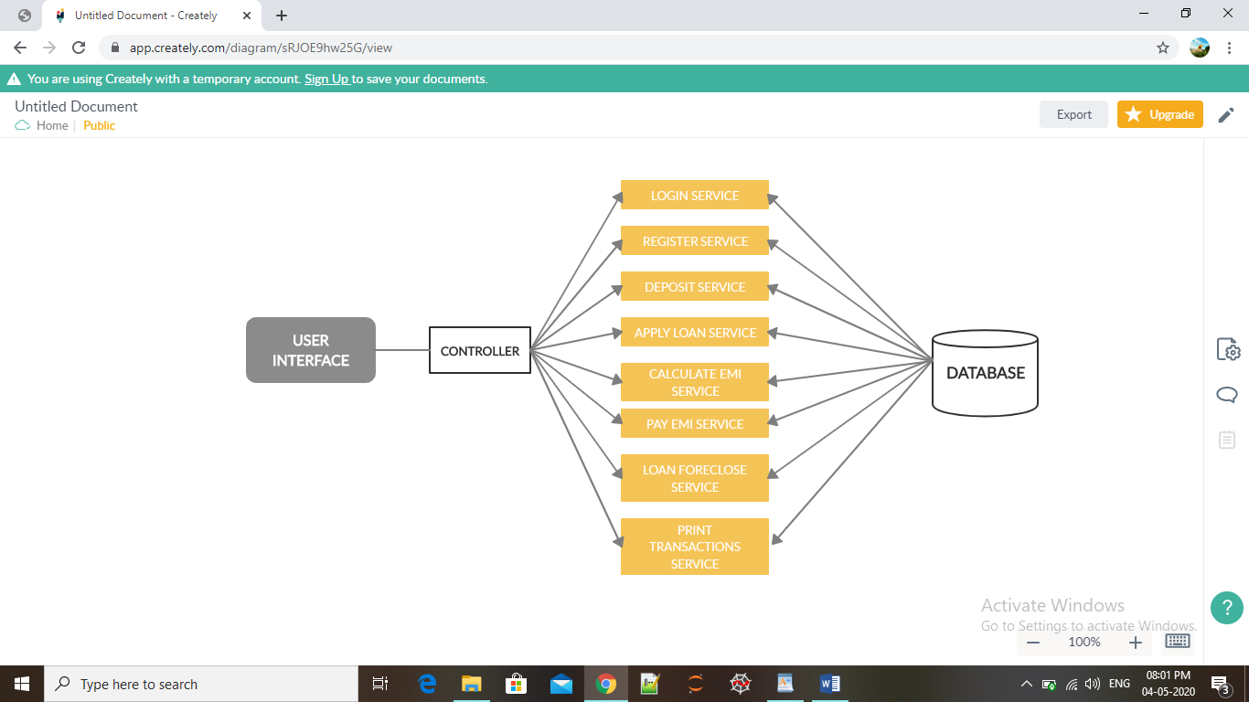

**Overall Entity Relationship Diagram:**

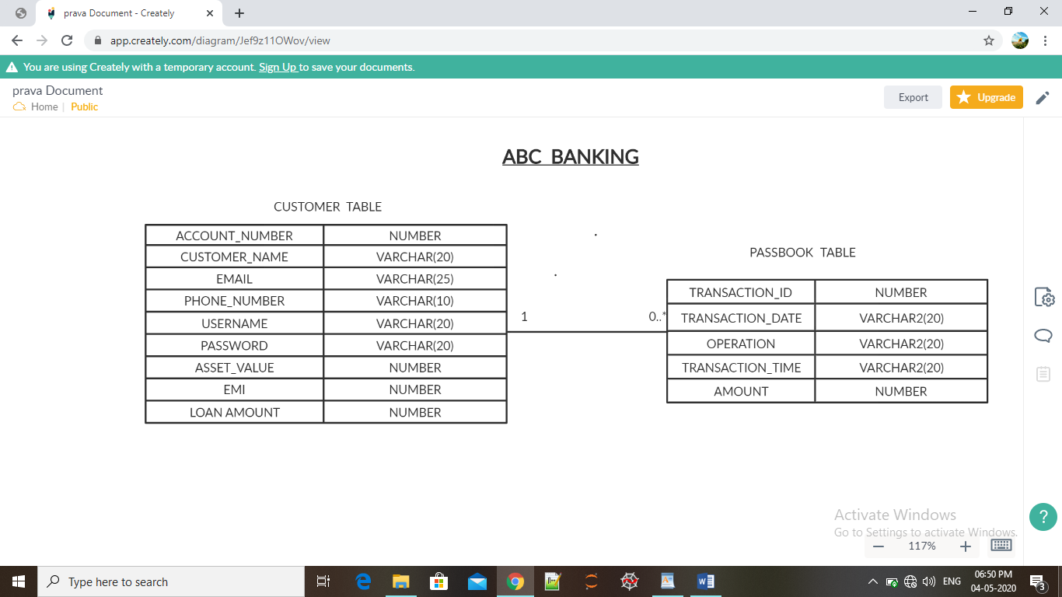

**Class Diagram:**

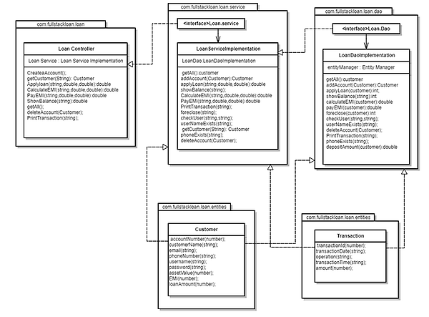

**Activity Diagrams:**

**Login:**

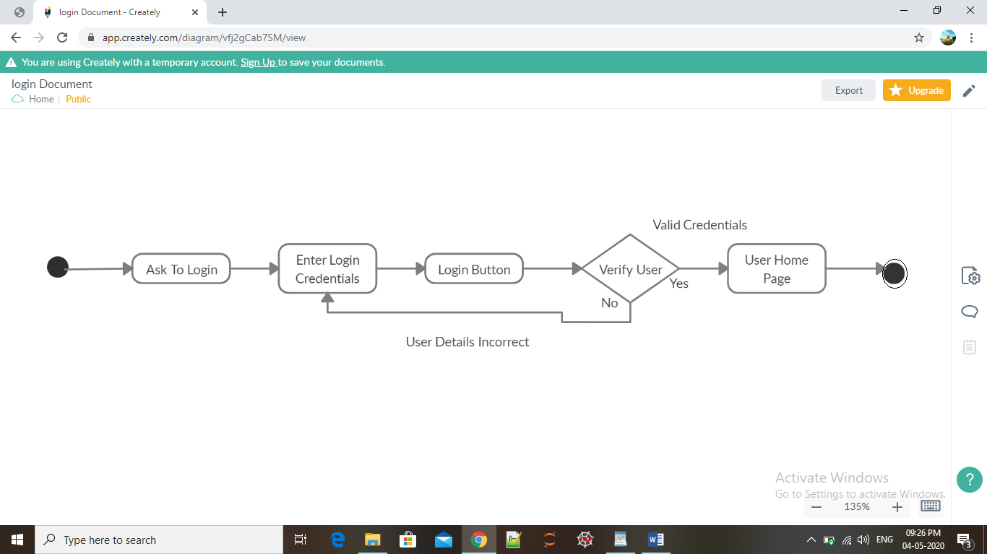

**Register/Sign Up:**

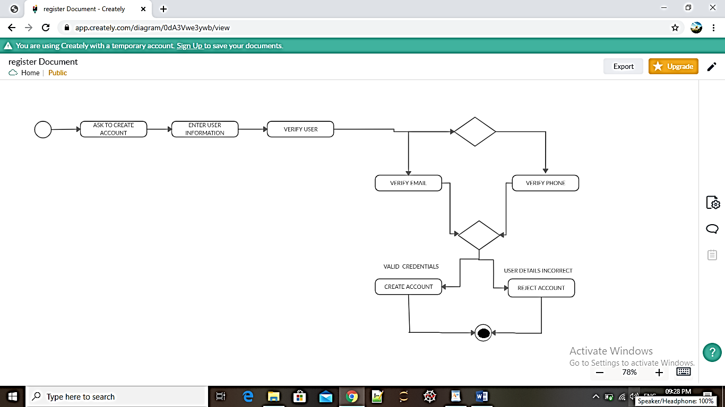

**Admin Login:**

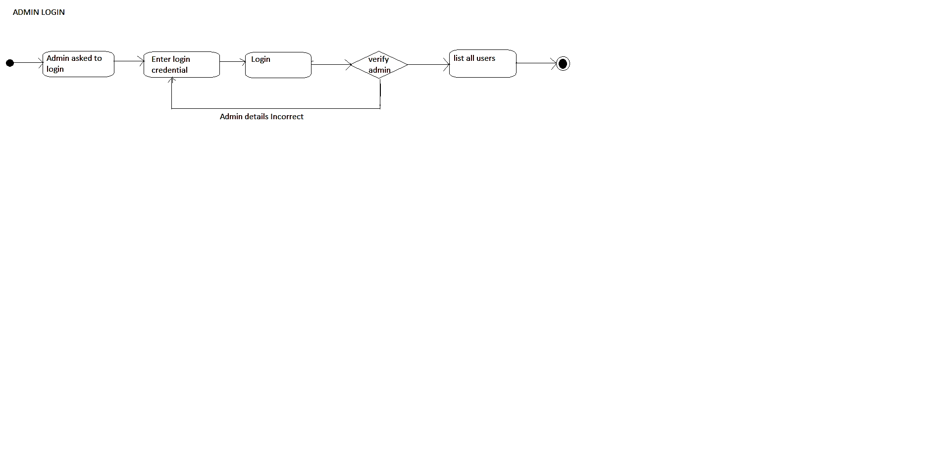

**Apply Loan:**

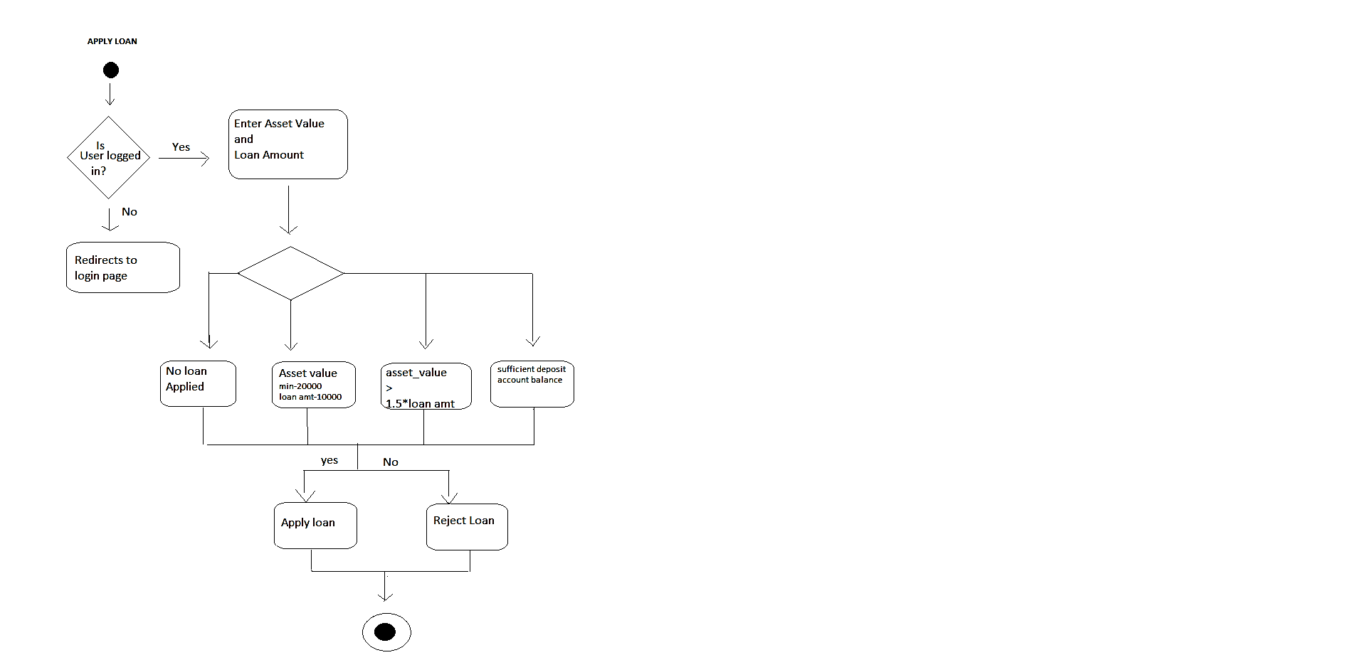

**Check Account Balance:**

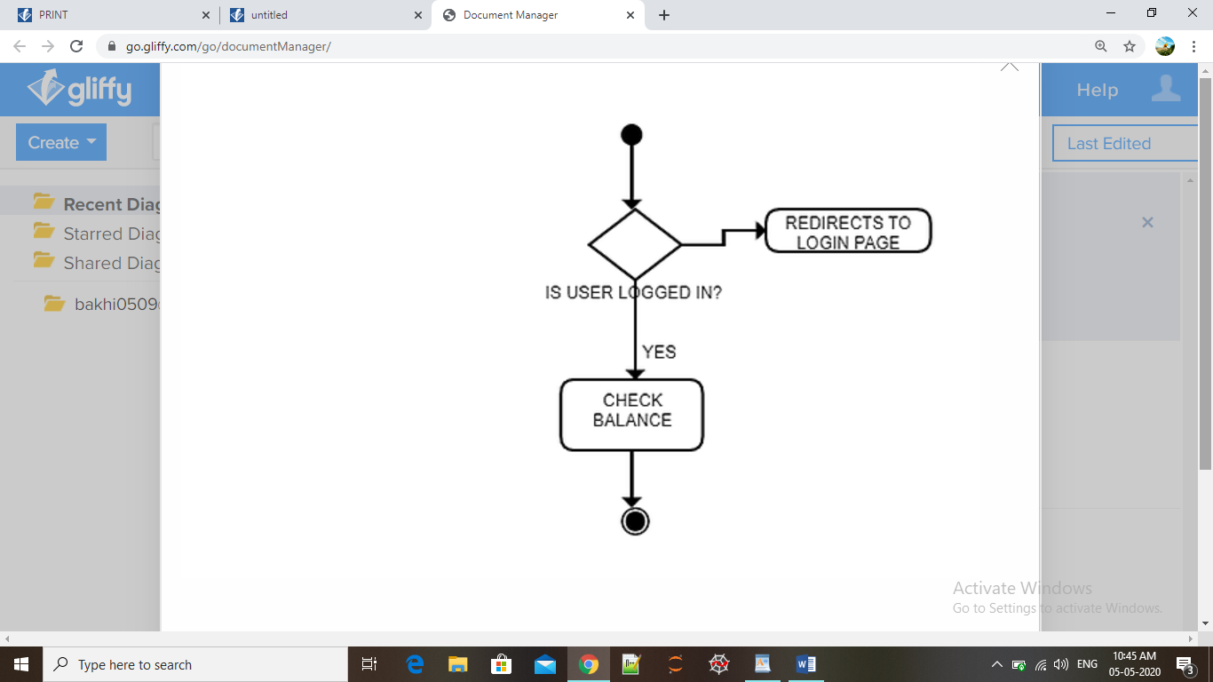

**Deposit Balance:**

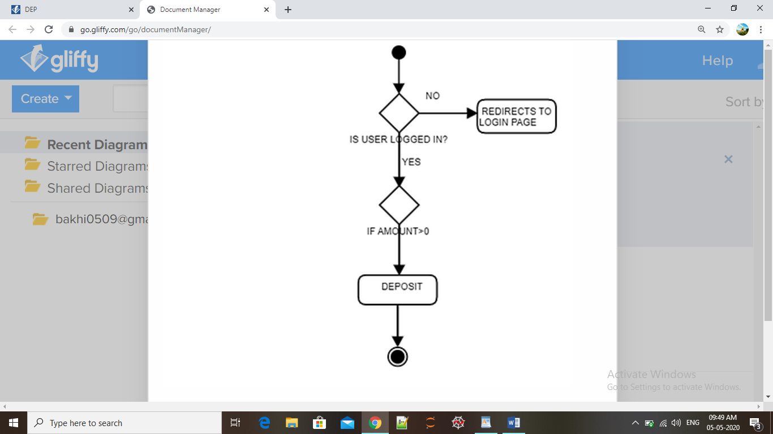

**Foreclose:**

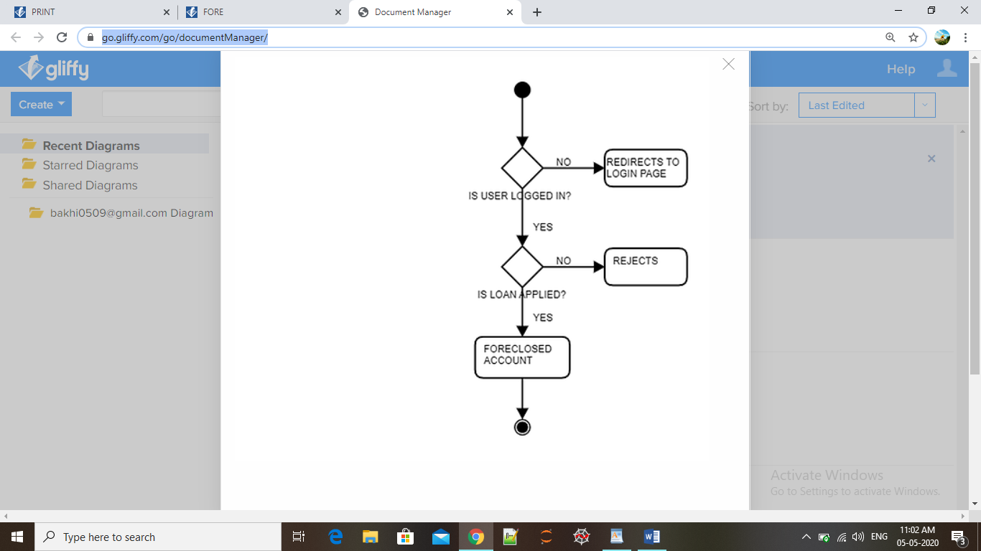

**Print Transactions:**

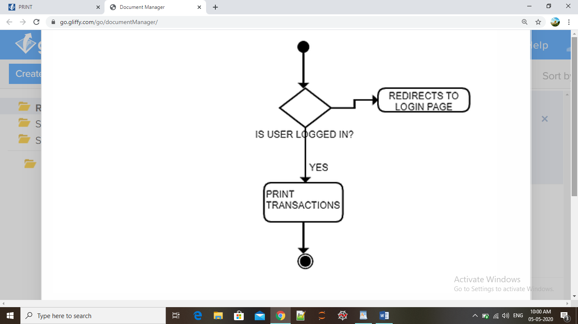

**Calculate EMI:**

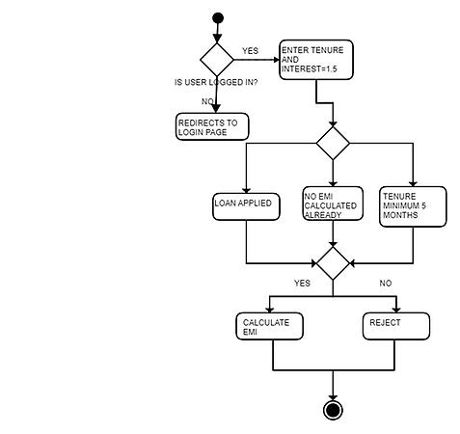

**Pay EMI:**

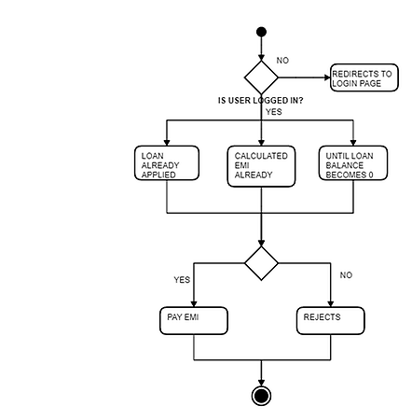

**Sequence Diagram:**

